Role Title: | Social Media Content Creator
Location: | Tuesdays in West Ashland Milton Keynes Support Office and another team day a week in London
Reports to Role: | TBC
Direct Reports: | None
Grade: | F
Notice Period: | 3 months
Version Number and date: | April 2025

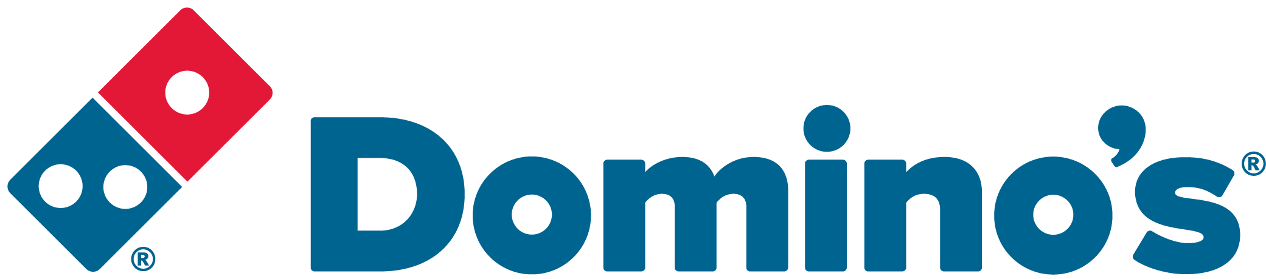ROLE PURPOSE
Our ambition is to make Domino’s one of the UK and Ireland’s most exciting and alluring brands. A key part of this is having consumer-facing social channels the public love. Working within the national marketing team at Domino’s, your focus will be to create exciting and alluring visual content fit for social across our UK channels – content that is designed to engage, be shared and stop thumbs from scrolling.

MAIN AREAS OF RESPONSIBILITY
- Responsible for creating organic social-first exciting and alluring content fit for Domino’s TikTok and Instagram channels in the UK and Ireland which drives impressions and engages audiences
- Weekly ideation and content creation aligning to Domino’s social content pillars, contribute to monthly analysis sessions reviewing content.
- Work collaboratively with Social Copy Writer and Social Media Manager to ensure all content leverages brand insights, consumer truths and data.
- Support the Social Media Manager in Domino’s gifting and creator programme. Working with suppliers to ensure campaigns are on time, on brand and fit for purpose.
- Avid user or social media, keeping up to date with latest trends and industry news.
- Manage own photoshoots and shot list with support from the Social Media Manager.
- Support on PR shoots to capture social content where necessary with support from the Social Media Manager.
- Proactively pitching content ideas and opportunities for Domino’s to make big noise on social.
- Be a collaborative part of Domino’s in-house social team.

ACCOUNTABILITY
- Comply with all legal and Company policies and procedures regarding health and safety to ensure you work in a manner that keeps you and your colleagues safe.
- Comply with all applicable UK and Ireland Data Protection and ePrivacy legislation and report non-compliances where identified to the Data Protection team
- Responsible for actively participating in Domino’s performance development process to ensure knowledge and skills remain current and relevant for role.

The main areas of responsibility are not intended to be exhaustive, but gives a general indication of the role. It is the nature of the Company that tasks and responsibilities are in many circumstances, unpredictable and varied. All colleagues are therefore, expected to work in a flexible way when the occasion arises and acknowledge that tasks not specifically covered in their role profile are not excluded.

KNOWLEDGE, SKILLS, ABILITY & EXPERIENCE
- High level of experience with content creation for Instagram and TikTok.
- Knowledge or experience of preferred editing tools (E.g. Adobe suite, Canva, Capcut etc.)
- Experience with capturing content for social channels on iPhone.
- A lover of keeping up with news and trends – knowledge of celebrities, football, gaming and TV/Streaming services a curiosity about internet culture and willingness to engage in community
- Experience with social media management tool Sprout Social (or similar) desirable
- Team player, collaborative worker
- Good judgment – a misstep in social media can lead to brand reputational issues
- Willing to work flexible hours and prioritise e.g. during a large football tournament or TV launch night

OUR VALUES


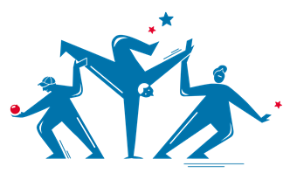
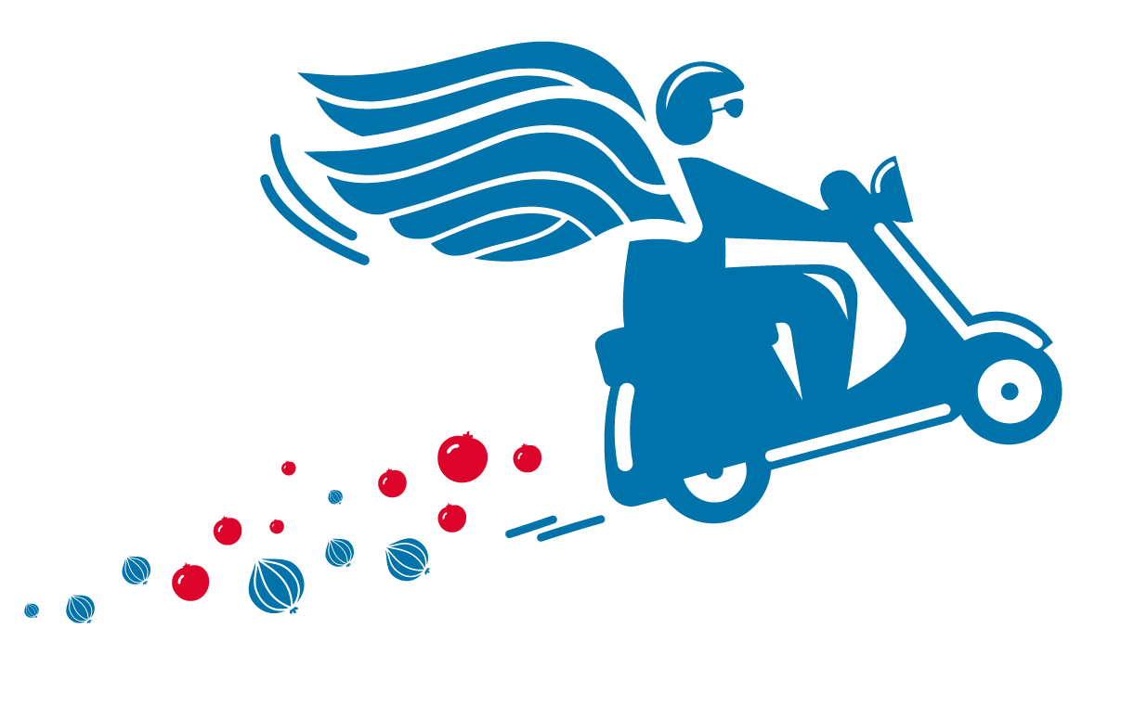

We grow and
win Together
We do the
right thing
We are
one team
We are
bold
We love customers

