Role Title: | Product Designer (Mid-Weight)
Location: | Head Office 1 day a week/ Remote
Reports to Role: | UX Manager
Direct Reports: | Nicola Lush
Grade:
Notice Period:
Version Number and date:

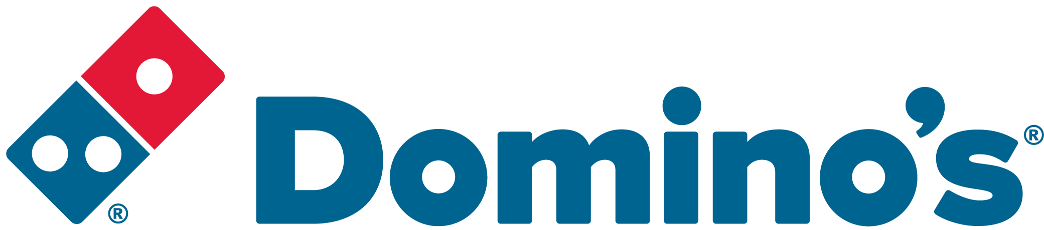ROLE PURPOSE
As a Mid-Weight Designer, you’ll play a crucial role in crafting seamless, visually engaging experiences across our App and Web platforms.
​
Working within the Product and UX team, you’ll collaborate closely with Product Managers, Developers, and other Designers to create interfaces that delight users and drive business results.
​
This is a hands-on design role, ideal for a creative problem-solver with experience in eCommerce design and a strong understanding of user-centred principles.

MAIN AREAS OF RESPONSIBILITY
- Working on App and Web designs for Domino’s eComm Experiences.
- Maintaining the production workstream by communicating and monitoring the projects life cycle. Updating project owners on the state of play and owning the project until its completion. This also involves updating project management tools with status and project notes. Working to deadlines and communicating effectively with the UX Manager.
- Collaborate with eCommerce Product Owners and Software Delivery Team to ensure projects are delivered on time and to standard. Communicating the projects limitations and providing effective solutions. Work with stakeholders to get internal feedback.
- Attend meetings to help develop solutions. Confidence and ability to present to wider business groups to communicate designs. This will involve taking on feedback and able to adapt solutions.
- Evaluate customers needs and help ensure there are a clear set of needs to be solved from the customers perspective. This will then be used to help form MVT tests.
- Ability for rapid ideation, using creative problem solving skills to identify solutions to meet customer needs and solve business problems.
- Creating pixel perfect designs for Mobile/ Tablet/ Desktop and App. This may also include some asset generation.
- When needed, create protoypes to help support user testing.
- Validate solutions through research and user testing to help broaden the teams knowledge for solutions.
- Prepare and document decisions for product changes, so they can be referred to by other members of the team.
- Work with the wider team to document design flows and experiences for hand off to development teams. This includes keeping up to date production files and ensuring that UI adheres to guidelines.
- UX review projects in their development phase to ensure that the concept has been built correctly. This may involve adapting designs while in build due to constraints.
- Working with the Big Dip studio to help generate appropriate supporting marketing assets for projects. Working with Marketing to ensure elements are on brand when required.
- Constantly increasing personal and team knowledge of latest UX/UI trends and features.
- Working with third party agencies.
- Travel to our Manchester/ Milton Keynes when required for team work.

- Comply with all legal and Company policies and procedures regarding health and safety to ensure you work in a manner that keeps you and your colleagues safe.
- Comply with all applicable UK and Ireland Data Protection and ePrivacy legislation and report non-compliances where identified to the Data Protection team
- Responsible for actively participating in Domino’s performance development process to ensure knowledge and skills remain current and relevant for role.

The main areas of responsibility are not intended to be exhaustive, but gives a general indication of the role. It is the nature of the Company that tasks and responsibilities are in many circumstances, unpredictable and varied. All colleagues are therefore, expected to work in a flexible way when the occasion arises and acknowledge that tasks not specifically covered in their role profile are not excluded.
ACCOUNTABILITY
- Maintaining current design libraries.
- Updating and maintaining guidelines.
- Ensuring any design changes are correctly documented and communicated.
- Aware of the impact of any design change across platforms.
- Ensuring designs adhere to correct usability standards such as colour blindness etc.
- Ensuring consistency across products.
- Approving of development builds from a UX perspective.
- Communication of projects progression to all stakeholders.
- UX reviews for project work.

KNOWLEDGE, SKILLS, ABILITY & EXPERIENCE
- At least 3-5 years experience working as a UX/UI designer in a digital industry.
- A formal degree or diploma from a reputable art/design college.
- An established portfolio of work to demonstrate your experience and ability.
- Background in design for web and interactive media. You will need to have knowledge of iOS/ Android and Internet browsers limitations and capabilities.
- Knowledge of eCommerce
- Experience with user interface design patterns/ component libraries
- Strong understanding of complex user journeys, user experience and user-centered design
- Proven understanding of typography, layout, colour and grid structures (e.g. Google Materials/ BBC GEL)
- Strong conceptualization ability, strong visual communication ability, drawing skills and sketchbook technique
- Exposure to fast moving working environments
- Experience in presenting to team members and justifying designs
- Experience in working with development and consulting in delivering UI
- Knowledge of MVT testing using tools such as Kibo/ Optimisely etc

Software Knowledge
- Knowledge of Adobe Creative Suite
- Knowledge design tools such as Figma
- Knowledge on using project management tools
- Experience of creating designs for responsive websites and mobile apps
- Use of online testing tools Usertesting.com, Kibo or similar
- Knowledge of prototyping tools such as Figma, Axure or similar
- Knowledge/understanding of HTML and CSS (non-essential)

OUR VALUES
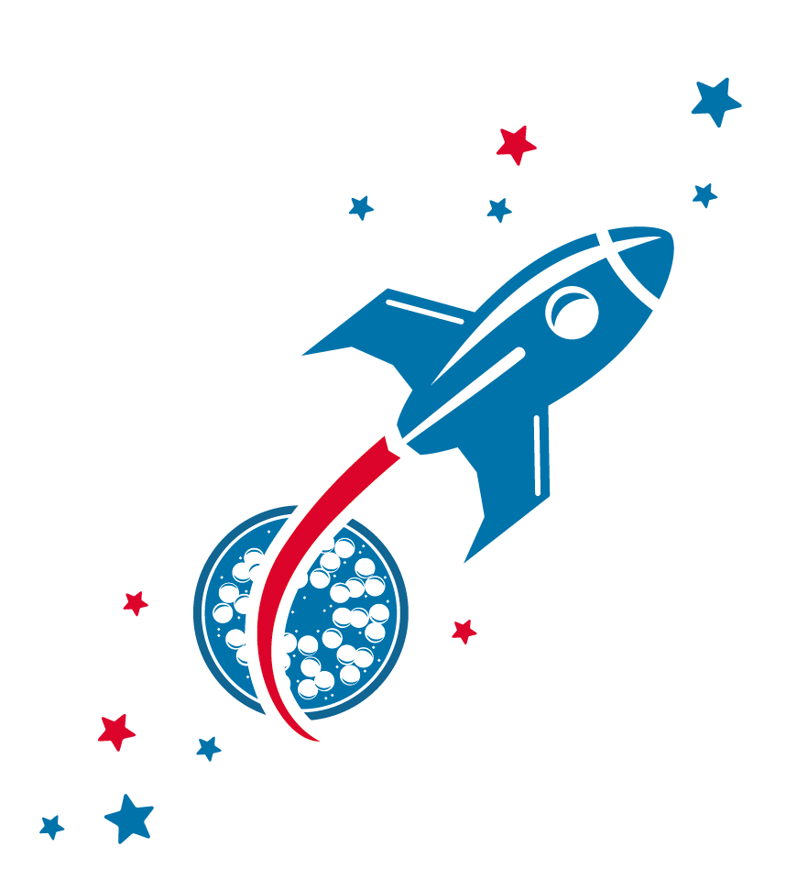
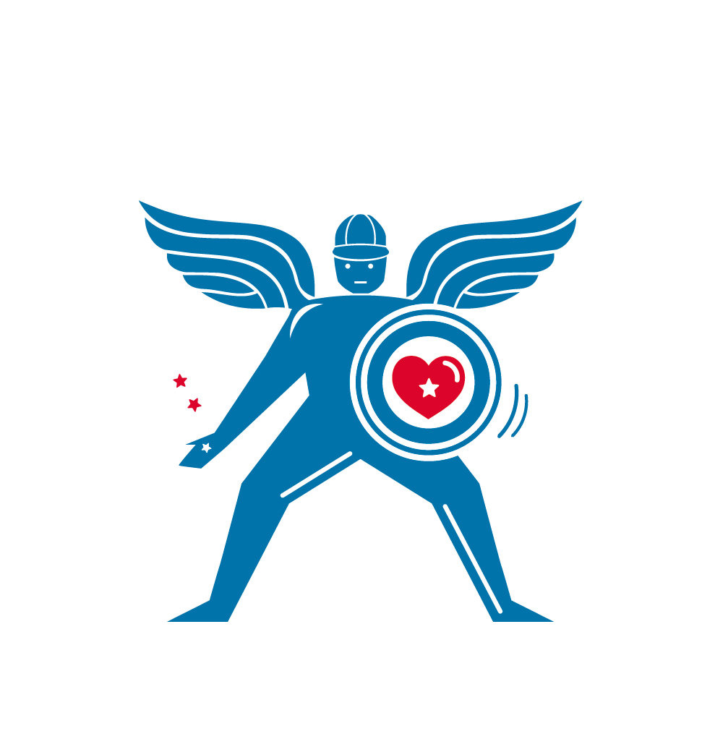
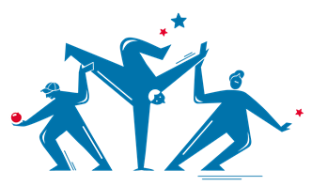
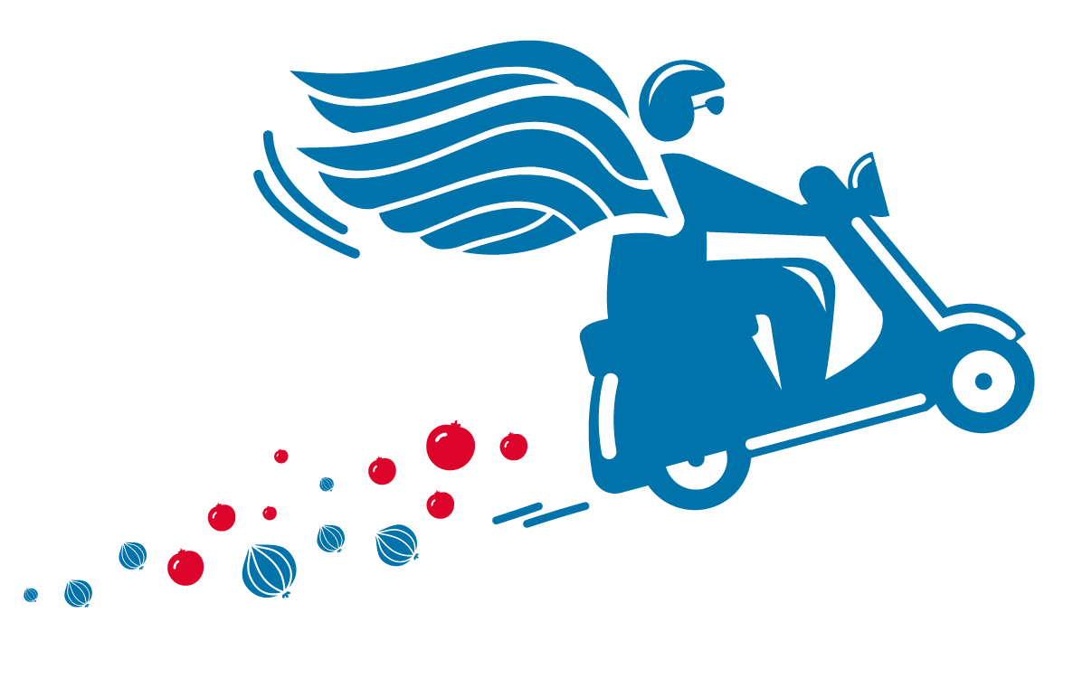
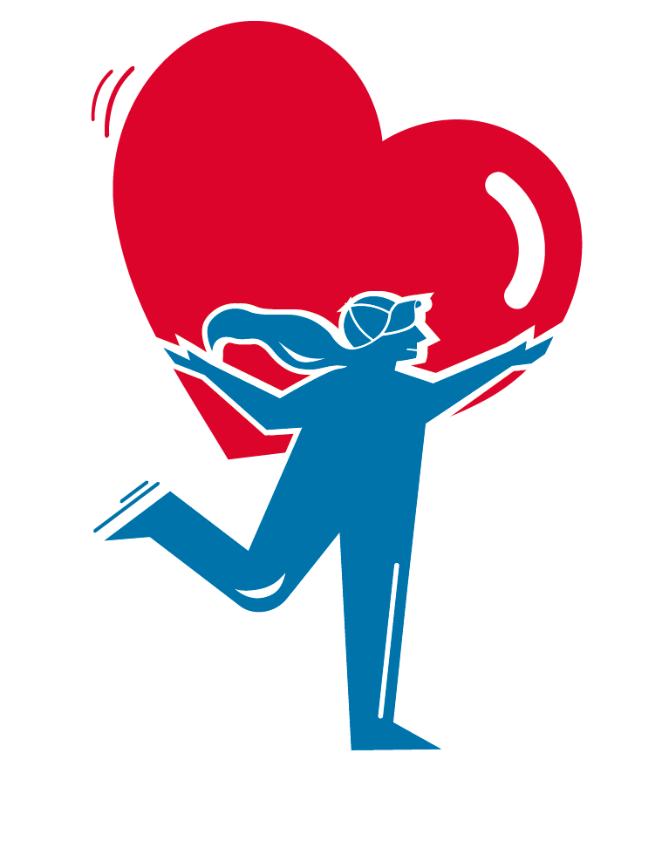
We grow and
win Together
We do the
right thing
We are
one team
We are
bold
We love customers

