Role Title: | Fleet Compliance Coordinator
Location: | Supply Chain Centres
Reports to Role: | Transport Shift Managers
Direct Reports: | None
Grade: | 6
Notice Period: | 4 weeks
Version Number and date: | May 2019

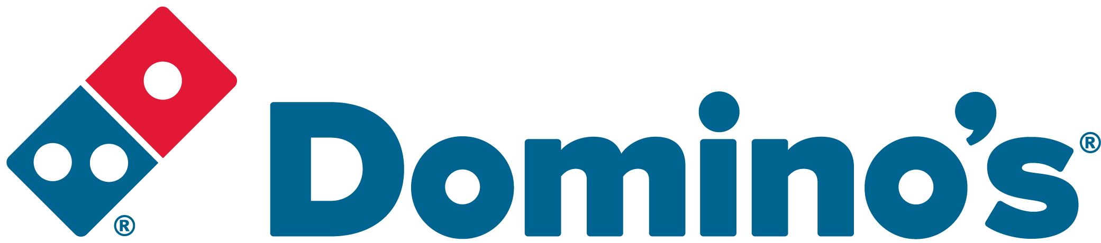ROLE PURPOSE
To monitor and maintain the legal compliance and operational efficiency of the delivery Domino’s Fleet in line with Domino’s Pizza policies and procedures.

MAIN AREAS OF RESPONSIBILITY
- In conjunction with other members of the Fleet Compliance Team, responsibility for the vehicle defect process and vehicle service planning and service schedule ensuring the optimum operational availability for the fleet and minimal vehicle downtime.
- Ensure vehicles are maintained, including servicing, MOT’s and accident repairs in line with company policy and legislation
- Liaising and assisting in managing the relationship with third party suppliers, in relation to vehicle accidents or damages and provide necessary information to Domino’s insurers.
- Proactively seek methods of continuous improvements and cost savings within the department and propose these to managers.
- Monitor the driver compliance management system and escalate any patterns / concerns as required.
- Purchase order maintenance; including weekly fuel purchase.
- Produce relevant reports and KPI information as required by the management team
- Comply with all legal and Company policies and procedures regarding health and safety to ensure you work in a manner that keeps you and your colleagues safe.
- Comply with all applicable UK and Ireland Data Protection and ePrivacy legislation and report non-compliances where identified to the Data Protection team
- Responsible for actively participating in Domino’s performance development process to ensure knowledge and skills remain current and relevant for role.
The main areas of responsibility are not intended to be exhaustive but gives a general indication of the role. It is the nature of the Company that tasks and responsibilities are in many circumstances, unpredictable and varied. All colleagues are therefore, expected to work in a flexible way when the occasion arises and acknowledge that tasks not specifically covered in their role profile are not excluded.

ACCOUNTABILITY
- Ensure legal compliance and co-operate with Company policy and procedure relating to ISO Standards and Food Hygiene Standards whilst in performance of duties and on Company premises.
- To maintain an up to date knowledge of all regulations related to their responsibilities.
- Continue to develop own talents and strengths and address any areas of self-development

KNOWLEDGE, SKILLS, ABILITY & EXPERIENCE
- Previous similar experience gained within a Transport environment, preferably with vehicle compliance
- A good working knowledge of Transport and vehicle legislation
- An understanding of Health and Safety and Food Safety legislation

COMPETENCIES
At Domino’s we recruit, develop and retain the best talent, we work hard and have fun along the way, and our colleagues are;
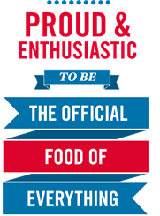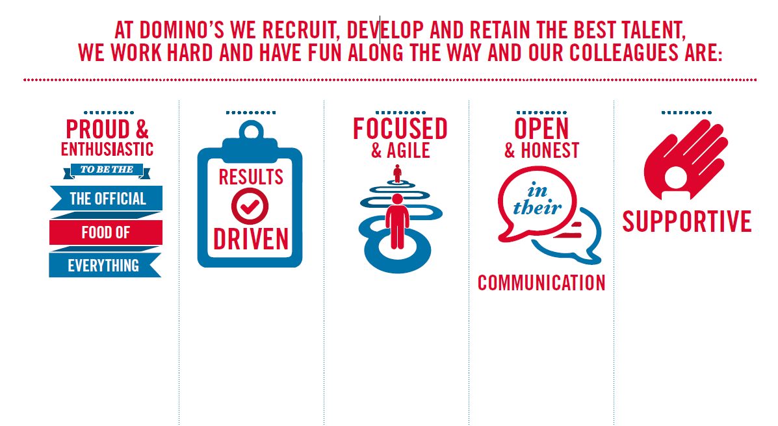
Proud & Enthusiastic: A positive advocate of their brand energises others through their passion.

Results Driven: Exceeds goals, pushes themselves to deliver, gets the job done at pace.

Focused & Agile: Works towards business goals, flexible to adapt and innovate as needed.

Open & Honest: Has sincere and two-way conversations, listens to and respects the views of others.

Supportive: Encourages and helps others, builds relationships, contributes to a positive environment

