Role Title: | Finance Analyst – Marketing & NAF
Location: | West Ashland
Reports to Role: | Finance Manager – Marketing, NAF & Innovation
Direct Reports: | None
Grade: | F
Notice Period: | 4 weeks
Version Number and date: | Oct 2025

ROLE PURPOSE
Purpose
Reporting to the Finance Manager – Innovation, Marketing and NAF (National Advertising Fund), the purpose of this role is to maintain the accounting records and support production of management accounts and supporting statutory information for the Marketing business and the National Advertising Fund.
Provide business support to the Marketing and Digital Marketing teams including the production of timely and accurate financial information, supported with analysis that allows the business to make better commercial decisions.
Provide business support to the National Advertising Fund (NAF), including the production of timely and accurate financial information, supported with analysis that can be shared with our franchisee community.

MAIN AREAS OF RESPONSIBILITY

- Responsible for end-to-end preparation of management accounts for the marketing function and the National Advertising Fund to ensure a robust and clean close each month
- Preparation and posting of monthly accruals and prepayment journals
- Build and maintain relationships with stakeholders at all levels
- Ensure balance sheet reconciliations are completed each period
- Support in the delivery of monthly management reports to ensure accurate and timely periodic reporting to budget, forecast etc. along with a full understanding of periodic variances and assessment of all risks and opportunities undertaken with the relevant budget holders each period
- Support the finance manager in the annual budget & five-year plan process for marketing and NAF to deliver a robust financial plan in line with company objectives
- Support in delivery of monthly financial reporting for the NAF to be shared with franchisees, ensuring accurate and timely period reporting against budget and a full understanding of the variances
- Ensure principles of allocation to the NAF are adhered to
- Ad-hoc project and financial reporting work where required
ACCOUNTABILITY

- Demonstrate a proactive approach to their responsibilities, being accountable for their workload during month end and ensuring deadlines are met
- Enjoy working as part of a team, with a positive attitude and willingness to get stuck in
- Be proactive, curious and eager to learn – someone who is always looking to improve processes, expand their knowledge and develop professionally
- Demonstrate a proactive approach to their professional development, including progression through relevant qualifications

KNOWLEDGE, SKILLS, ABILITY & EXPERIENCE

- Part qualified or newly qualified accountant
- Strong understanding of core accountain principles, including accruals, prepayments and balance sheet reconciliations
- Motivated and collboarative individual who combines strong financial acumen with a proactive, team oriented mindset
- The desire to challenge existing processes and implement positive change with a hands-on style
- Demonstrate confidence in working with Excel and good analytical skills
- Experience of producing and presenting financial information to finance and non-finance stakeholders
- Excellent attention to detail
- Responsive/agile working style with the ability to prioritise
- Ability to effectively communicate at all levels and provide easy to understand commentary and investment papers

COMPETENCIES

At Domino’s we recruit, develop and retain the best talent, we work hard and have fun along the way, and our colleagues are;
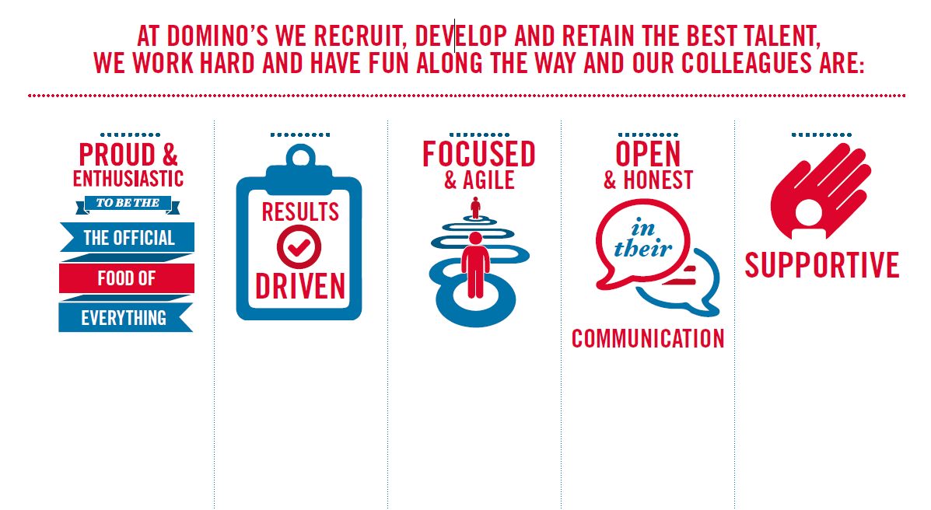
Proud & Enthusiastic: A positive advocate of their brand energises others through their passion.

Results Driven: Exceeds goals, pushes themselves to deliver, gets the job done at pace.

Focused & Agile: Works towards business goals, flexible to adapt and innovate as needed.

Open & Honest: Has sincere and two-way conversations, listens to and respects the views of others.

Supportive: Encourages and helps others, builds relationships, contributes to a positive environment

