Role Title: | Legal Counsel 8 Years + PQE
Location: | Milton Keynes Head Office (2-3 days) / Remote
Reports to Role: | Head of Legal & DPO
Direct Reports: | 0
Grade: | E
Notice Period: | 12 weeks
Version Number and date: | V1 January 2026

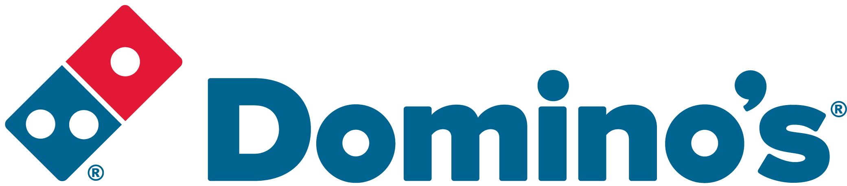ROLE PURPOSE
The purpose of the role is to support and advise the publicly quoted business with operations in the UK and ROI and ensure legal compliance across all departments and territories.

To provide legal assistance to the Domino’s Pizza Group plc group companies. Carrying out a general commercial role and providing legal insights and advice to leadership teams on a wide range of legal matters.

MAIN AREAS OF RESPONSIBILITY
Operational day-to-day activities shall include:
- Commercial contracts: receiving, checking, advising and amending legal documentation for all areas of the business including contracts with suppliers, agencies and general third parties.

- Marketing & Advertising: in partnership with the Marketing Team, working on adverts, menus and competitions (including advising on appropriate terms and conditions), dealing with regulatory and licensing issues and negotiating multi million pound sponsorship agreements.

- Data Protection: ensuring the business and its franchisees are compliant from a data protection perspective in terms of direct marketing and ensuring compliance with the Group’s responsibilities as a data controller and franchisor. Advising on and negotiating Data Processing Agreements, supplier contracts and international data transfers.

- Brand Protection: responsible for protecting and enforcing the group’s intellectual property rights and minimising any misuse of the brands trademarks and copyright. Responsible for advising on complaints and issues that have been escalated to the Legal Department.

- Standard Franchise Agreement (SFA) compliance: providing guidance and advice in relation to the SFAs.

- Finance: supporting and working on banking arrangements and issuing and creating loan agreements.

- General: supporting all teams within the business from a legal perspective in the UK and ROI. Dealing with complex matters with limited supervision and providing guidance and advice to the more junior members of the team.

- Comply with all legal and Company policies and procedures regarding health and safety to ensure you work in a manner that keeps you and your colleagues safe.
- Comply with all applicable UK and Ireland Data Protection and ePrivacy legislation and report non-compliances where identified to the Data Protection Officer
- Responsible for actively participating in Domino’s performance development process to ensure knowledge and skills remain current and relevant for role.

The main areas of responsibility are not intended to be exhaustive, but gives a general indication of the role. It is the nature of the Company that tasks and responsibilities are in many circumstances, unpredictable and varied. All colleagues are therefore, expected to work in a flexible way when the occasion arises and acknowledge that tasks not specifically covered in their role profile are not excluded.
ACCOUNTABILITY
- Provide accurate and timely advice to the business
- Use own judgement knowing when appropriate to escalate
- Keep up to date with legal changes/updates
- Work to deadlines managing own time accordingly
- Provide training, guidance, supervision and support to junior members of the team

KNOWLEDGE, SKILLS, ABILITY & EXPERIENCE
- A qualified solicitor with between 8+ years PQE
- Competence in the use of IT tools including Word and PowerPoint
- An ability to simplify complex issues
- Strong communication skills
- Resilience
- Efficiency
- Organisation
- A keenness to take on challenges
- A willingness to learn
- Flexibility
- Ability to work autonomously but understand when appropriate to escalate issues outside own level of expertise/knowledge
- Sound judgement
- Work to a high standard of accuracy
- Ability to work to deadlines in a fast paced environment

COMPETENCIES
At Domino’s we recruit, develop and retain the best talent, we work hard and have fun along the way, and our colleagues are;
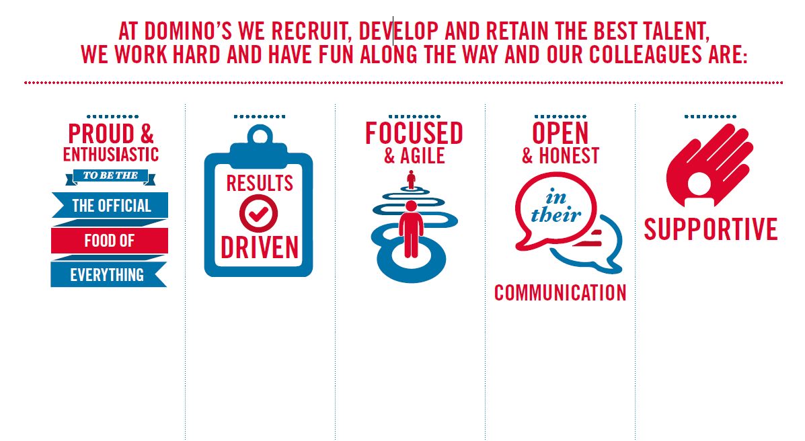
Proud & Enthusiastic: A positive advocate of their brand energises others through their passion.

Results Driven: Exceeds goals, pushes themselves to deliver, gets the job done at pace.

Focused & Agile: Works towards business goals, flexible to adapt and innovate as needed.

Open & Honest: Has sincere and two-way conversations, listens to and respects the views of others.

Supportive: Encourages and helps others, builds relationships, contributes to a positive environment

