Role Title: | Quality Assurance Manager (Supply Chain Centre)
Location: | Cover Naas and Cambuslang sites
Reports to Role: | Group Technical Manager
Direct Reports: | 0
Grade:
Notice Period: | Business Critical
Version Number and date: | V1 February 2021

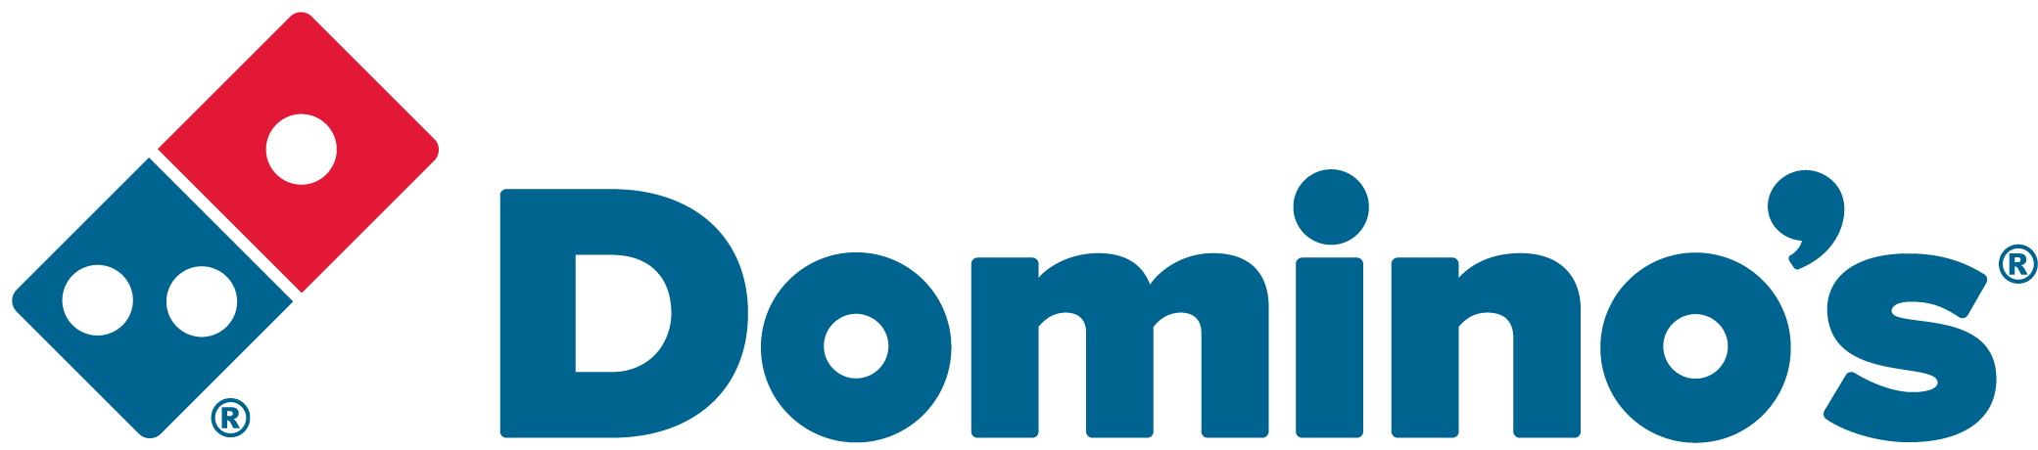ROLE PURPOSE
Ensure all Domino’s group procedures are correctly implemented at a site level and in line with the quality management system. On site representative to drive the agenda for food safety, legislation and quality across manufacturing, storage and distribution. Ensuring compliance to external certification and internal standards and policy. Ensure Domino’s brand values are upheld and meet the needs and expectations of our customers.

MAIN AREAS OF RESPONSIBILITY
- Support the maintenance of the Quality Systems Manual for Cambuslang and Naas Supply Chain Centre, ensuring that the physical factory and its operation provide for food safety, consistently meet stores and legal requirements, and work towards best practice.
- Validate compliance to FSQMS through audits, product testing, verification exercises.
- Conduct GMP and hygiene audits across manufacturing sites including intake, production, warehouse and transport for compliance and notify appropriate stakeholders of corrective action if non-compliance is detected.
- Review of supplier Certificates of Analysis for key ingredients ensuring all are appropriately filed.
- Management of procedures, SOPs and records, including the writing and modification of documents used by Warrington to ensure consistency across all sites.
- Driving improvement in the Quality Management System through Document Control, management of non-conformances and complaints
- To manage, along with the management team on site, the achievement of key performance indicators and identify improvements required to meet KPI’s and develop plans to achieve.
- Validate and verify compliance through audits and testing, both announced and unannounced to ensure brand integrity for the manufacturing, distribution and storage sites.
- Responsible for preparing the site for and managing audits and visits conducted by statutory bodies and second- or third-party auditing bodies, ensuring closure on actions.
- Accountable for reporting performance to business stakeholders and working together to identify trends and strategies for improving overall site performance including: Microbiological Standards, GMP Standards, Hygiene Standards, Customer Complaints, Non-Conformances, Product Quality.
- Provide support whilst dealing with crises and issues, providing technical expertise and insight to resolve problems with minimal disruption to the business.
The main areas of responsibility are not intended to be exhaustive but gives a general indication of the tasks involved. It is the nature of the Company that tasks and responsibilities are in many circumstances, unpredictable and varied. All colleagues are therefore, expected to work in a flexible way when the occasion arises and acknowledge that tasks not specifically covered in their role profile are not excluded.
ACCOUNTABILITY
- Legal, food safety and health and safety compliance.
- Drive the culture of continuous improvements for the manufacturing and storage facilities.
- Ensure compliance following audits and testing.
KNOWLEDGE, SKILLS, ABILITY & EXPERIENCE
- Experience of working to standard operating procedures
- Management experience ideally within a factory environment
- Food Technology/Science degree
- Knowledge and practice of auditing and assessing
- GMP, hygiene and pest control
- Ability to translate complex data into understandable information for a variety of stakeholders (particularly outside of the Technical team)
- Excellent communication skills at all levels demonstrating ability to both influence and challenge stakeholders
- Able to work collaboratively with all areas of the business building good internal and external relationships
- Ability to challenge existing practices and manage change with a strategic and pragmatic approach

COMPETENCIES
At Domino’s we recruit, develop and retain the best talent, we work hard and have fun along the way, and our colleagues are;
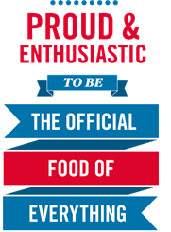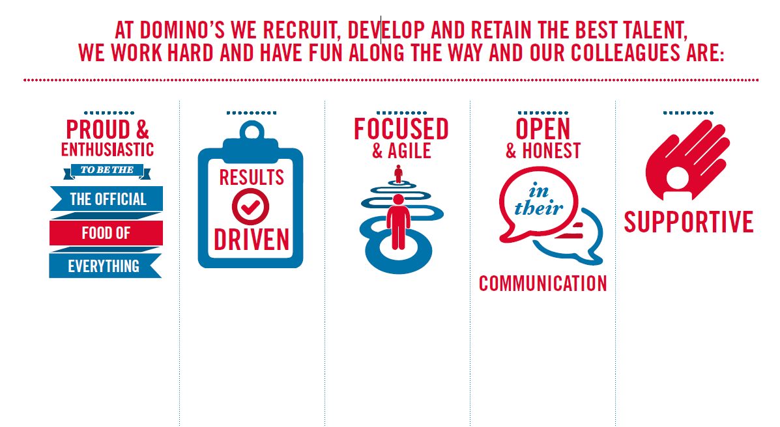
Proud & Enthusiastic: Understading of functional area, acting as a coach to passionately inspire, motivate
and share knowledge with others to achieve success

Results Driven: Sets and maintains high performance standards with ability to problem solve,
motivating self and others to translate action plans in to results

Focused & Agile: Acts with customers in mind at all times, prioritising what will make a difference to
colleagues, customers and franchisees

Open & Honest: Excellent communications skills encouraging two way positive and developmental
feedback at all levels

Supportive: Strong interpersonal and influencing skills to build and maintain networks internally
and across the business to collaboratively achieve results

