Role Title: | Van Driver
Location: | Supply Chain
Reports to Role: | Transport Shift Manager
Direct Reports: | N/A
Grade: | 6
Notice Period: | 1 Week
Version Number and date: | May 2019

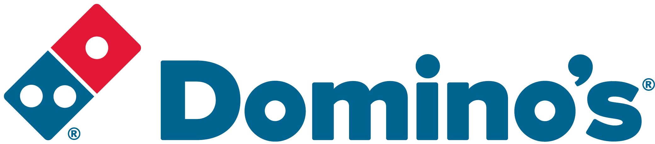ROLE PURPOSE
Ensure the accurate, safe and timely delivery of goods to Domino’s Pizza Stores throughout the UK and Ireland in line with Domino’ Pizza policies and standard operating procedures.

MAIN AREAS OF RESPONSIBILITY
- Delivery of goods into Domino’s Pizza Stores by handballing product placing goods in the designated areas whilst ensuring the accuracy checking the goods delivery against the delivery paperwork.
- Comply with all Transport legislation including Working Time Directive, EU Driver’s Hours and Tachograph laws.
- To comply with all Company procedures ensuring that all paperwork associated with the role is completed accurately and returned to the Transport Office in a timely manner.
- Notify the Transport Office at the earliest opportunity of any delays to your deliveries, if you are unable to make a delivery and if you are likely to run out of driving hours prior to completing all your deliveries.
- Collection of empty dough trays from Domino’s Stores for return to the Supply Chain Centre
- Comply with all legal and Company policies and procedures regarding health and safety to ensure you work in a manner that keeps you and your colleagues safe.
- Comply with all applicable UK and Ireland Data Protection and ePrivacy legislation and report non-compliances where identified to the Data Protection team
- Report any vehicle defects to the Transport Office at the earliest opportunity.
- Responsible for actively participating in Domino’s performance development process to ensure knowledge and skills remain current and relevant for role.

The main areas of responsibility are not intended to be exhaustive but gives a general indication of the role. It is the nature of the Company that tasks and responsibilities are in many circumstances, unpredictable and varied. All colleagues are therefore, expected to work in a flexible way when the occasion arises and acknowledge that tasks not specifically covered in their role profile are not excluded.

ACCOUNTABILITY
- Maintain a working knowledge of all of the businesses within the Domino’s Group
- Participate in maintaining and developing the strong working relationship between Domino’s Pizza Group and it’s franchisee’s.
- Ensure an impressive service delivery to our Franchisee’s

KNOWLEDGE, SKILLS, ABILITY & EXPERIENCE
- Ideally at least 1 years’ current multi-drop driving experience
- An understanding of Health and Safety and Food Safety legislation
- A good working knowledge of Road Safety Act and Driver Legislation

COMPETENCIES
At Domino’s we recruit, develop and retain the best talent, we work hard and have fun along the way, and our colleagues are;
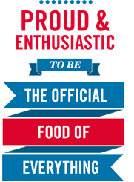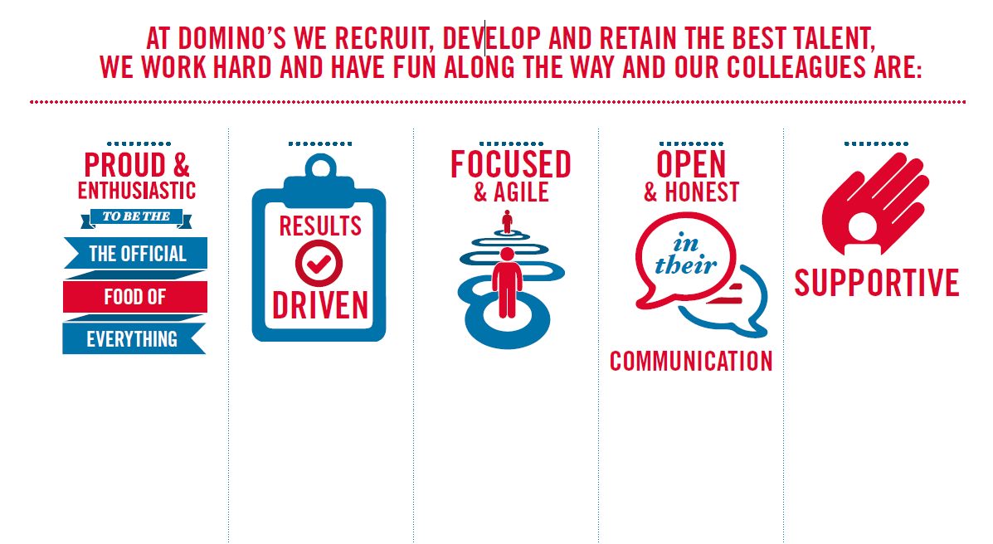
Proud & Enthusiastic: A positive advocate of their brand energises others through their passion.

Results Driven: Exceeds goals, pushes themselves to deliver, gets the job done at pace.

Focused & Agile: Works towards business goals, flexible to adapt and innovate as needed.

Open & Honest: Has sincere and two-way conversations, listens to and respects the views of others.

Supportive: Encourages and helps others, builds relationships, contributes to a positive environment

