Role Title: | IT Service Desk Analyst
Location: | Head Office
Reports to Role: | Service Desk Shift Leader
Direct Reports: | N/A
Notice Period: | 4 Weeks
Version Number and date: | Version 0.2 Date: 05/06/2023

ROLE PURPOSE
The Service Desk Analyst manages the end-to-end fulfilment and resolution of IT technical faults and enquiries as well as customer calls. This diverse role ensures timely response enabling stores and franchisees to run their businesses.

MAIN AREAS OF RESPONSIBILITY
- Overseeing the production of all Service Desk issues, within your remit, to ensure objectives are met.
- In line with our policy, ensure the principle of Treating Customers Fairly is an intrinsic part of the organization’s culture by identifying, monitoring, and managing any risks to either Domino’s Pizza or the Franchisees businesses.
- Field incoming help and service requests from end customers via both telephone and e-mail in a calm and welcoming manner and resolve within the agreed Service Level.
- Utilizing listening and questioning techniques to ascertain the issue being experienced, the impact and criticality to the customer.
- Prioritize and schedule all help and service requests tickets, channeling them to the appropriate resolver groups and functions. Co-coordinating with second- and third-line support groups for speedy resolution when required.
- Occasional travel to support the opening of new stores and reopening of existing stores post refurbishment.
- Monitor and escalate progress as appropriate to the severity of the issue and according to the SLA (where applicable), invoking escalation and major incident processes as required.
- Ensure at least 70% (call to ticket ratio) is being logged to meet the required standard.
- Be able to offer general advice, points of contact and guidance on all IT services available and ensure closure of tickets where resolution has been verified to the customer.
- Participate in shift pattern covering Service Desk hours of operation (early, late and night shifts)
- Comply with all legal and Company policies and procedures regarding health and safety to ensure you work in a manner that keeps you and your colleagues safe.
- Comply with all applicable UK and Ireland Data Protection and ePrivacy legislation and report non-compliances where identified to the Data Protection team
- Responsible for actively participating in Domino’s performance development process to ensure knowledge and skills remain current and relevant for role.

The main areas of responsibility are not intended to be exhaustive but gives a general indication of the role. It is the nature of the Company that tasks and responsibilities are in many circumstances, unpredictable and varied. All colleagues are therefore, expected to work in a flexible way when the occasion arises and acknowledge that tasks not specifically covered in their role profile are not excluded.

ACCOUNTABILITY
- Channeling requests for help to appropriate functions for resolution, monitoring progress and keeping the customer informed.
- Record, track and document the request ticket lifecycle; make an initial assessment agreeing next course of action with the customer, keeping them informed on status and progress.
- Identify any immediate corrective action that can resolve or contain the issue directly. Applying diagnostic utilities, FAQ’s and knowledge bases to aid in troubleshooting.

KNOWLEDGE, SKILLS, ABILITY & EXPERIENCE
Essential
- Must be educated to a minimum of GCSE level (or equivalent) including Maths and English (C or above)
- Good Microsoft skills using Outlook, Word and Excel
- Good customer service skills
- Ability to work in a busy, results focused and thriving environment
- Able to think logically and problem solve

Desirable:
- Basic understanding of IT technologies and support principles
- A true interest in IT and a desire to develop skills and knowledge in this area
- A+ qualification or equivalent

COMPETENCIES
At Domino’s we recruit, develop and retain the best talent, we work hard and have fun along the way, and our colleagues are;
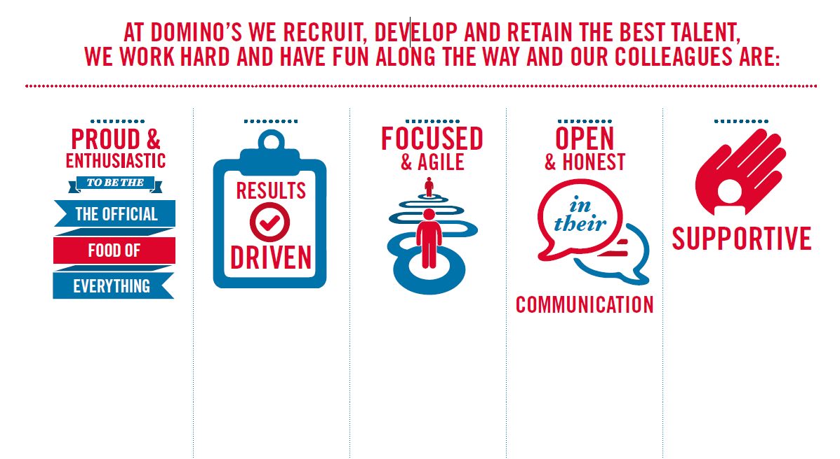
Proud & Enthusiastic: A positive advocate of their brand energises others through their passion.

Results Driven: Exceeds goals, pushes themselves to deliver, gets the job done at pace.

Focused & Agile: Works towards business goals, flexible to adapt and innovate as needed.

Open & Honest: Has sincere and two-way conversations, listens to and respects the views of others.

Supportive: Encourages and helps others, builds relationships, contributes to a positive environment

