Role Title: | eCommerce Analytics Manager
Location: | Head Office, Milton Keynes (remote)
Reports to Role: | Head Digital Data
Direct Reports: | one
Grade:
Notice Period: | 12 Weeks
Version Number and date: | June 2023 v1

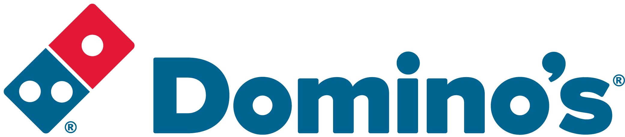ROLE PURPOSE
As the eCommerce Analytics Manager, you will play a pivotal role in shaping Domino’s digital strategy, driving business growth through data-led decision making. You will be responsible for delivering actionable insights that directly influence conversion rates, session budgeting, and overall digital performance. Your expertise will empower the business to optimise customer journeys, maximise commercial outcomes, and maintain a competitive edge.
You will lead the analytics function, championing a culture of continuous improvement and innovation. Through advanced analytics, you will ensure that Domino’s remains at the forefront of digital excellence, supporting both customer and franchisee success.

MAIN AREAS OF RESPONSIBILITY
- Lead the development and execution of conversion and session budgeting strategies, ensuring optimal allocation of digital resources to maximise ROI.
- Own the production and delivery of high-impact reports for the weekly trading meeting, providing clear, actionable insights that drive commercial decisions.
- Oversee conversion rate optimisation initiatives, utilising A/B and multivariate testing to enhance user experience and drive revenue growth.
- Manage and mentor a team of analysts, fostering a high-performance culture and supporting professional development.
- Build and maintain robust analytics frameworks using tools such as Google Analytics, Big Query, Power BI, SQL and Python.
- Collaborate cross-functionally with Data & Insights, Digital, Marketing, Product teams to promote the value of digital analytics and drive strategic opportunities.
- Automate reporting processes and dashboards to streamline performance tracking and enable agile decision making.
- Engage with senior stakeholders to ensure analytical insights are embedded in company and franchisee strategies.
- Champion the use of data to identify opportunities, address challenges, and prioritise initiatives that deliver the greatest business impact.
The main areas of responsibility are not intended to be exhaustive but gives a general indication of the role. It is
the nature of the Company that tasks and responsibilities are in many circumstances, unpredictable and varied.
All colleagues are therefore, expected to work in a flexible way when the occasion arises and acknowledge that
tasks not specifically covered in their role profile are not excluded.

ACCOUNTABILITY
- Lead app and web analytics, providing strategic direction and oversight across Domino’s digital platforms.
- Manage Google Analytics implementation and ensure data integrity for accurate performance measurement.
- Drive the creation of digital reporting dashboards and respond to ad-hoc data requests with speed and precision.
- Deliver franchisee analytics packs, enabling store-level performance improvements through targeted insights.
- Work autonomously, applying sound judgement and innovative thinking to resolve complex queries and escalate where necessary.
- Partner with senior stakeholders to educate, inform, and influence decisions that enhance the customer experience.
KNOWLEDGE, SKILLS, ABILITY & EXPERIENCE
- 4+ years’ experience in data analysis, ideally within a B2C or retail environment.
- Advanced proficiency in Google Analytics and SQL, with experience handling complex, multi-source datasets.
- Proven track record in conversion rate optimisation and session budgeting within eCommerce.
- Strong dashboarding and reporting skills (Tableau, PowerBI, DataStudio preferred).
- Experience in statistical modelling and customer analytics (churn, lifetime value, segmentation).
- Demonstrated ability to manage and develop high-performing teams.
- Agile/Scrum experience and a passion for innovation.

The candidate must be comfortable in a fast-paced environment using Scrum/Agile working practices. Must be prepared to do a lot of the ‘leg work’ for the team by finding out what the Business wants and covering all foreseeable scenarios.

Domino’s likes to innovate so the candidate will be encouraged to develop new ideas to help the business grow and become more efficient.
COMPETENCIES
At Domino’s we recruit, develop and retain the best talent, we work hard and have fun along the way, and our colleagues are;
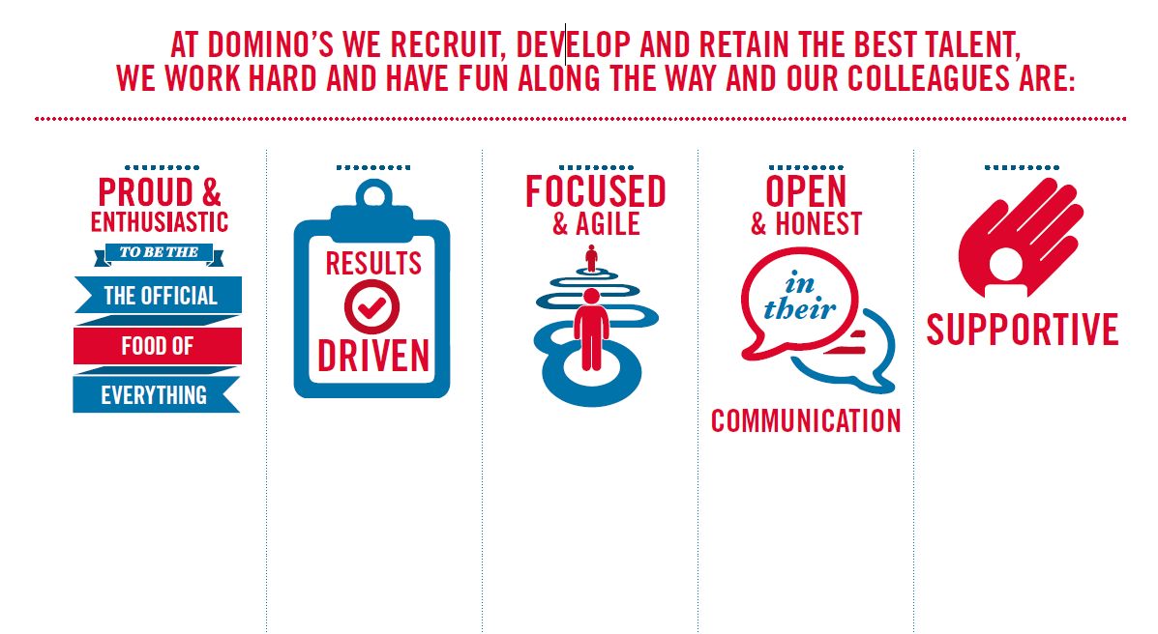
Proud & Enthusiastic: A positive advocate of their brand energises others through their passion.

Results Driven: Exceeds goals, pushes themselves to deliver, gets the job done at pace.

Focused & Agile: Works towards business goals, flexible to adapt and innovate as needed.

Open & Honest: Has sincere and two-way conversations, listens to and respects the views of others.

Supportive: Encourages and helps others, builds relationships, contributes to a positive environment

