Role Title: | Warehouse Team Leader
Location: | Supply Chain Centres
Reports to Role: | Warehouse Shift Managers
Direct Reports: | None
Grade: | 6
Notice Period: | 4 weeks
Version Number and date: | May 2019

ROLE PURPOSE
To support the Warehouse Shift Managers in delivering consistent performance overseeing the day to day running of the warehouse operations, helping to ensure that all daily targets are met in the most cost effective, efficient and safe manner, supporting aspects of team performance whilst encouraging/leading continuous improvement activities within the department.

MAIN AREAS OF RESPONSIBILITY
- Lead, motivate and supervise a team of Warehouse Operatives, ensuring a fully engaged team who work effectively to meet agreed KPI’s
- Participate in managing the day to day activities within the Warehouse whilst sharing activities on the Warehouse floor with Operatives as required.
- Manage the resource of Warehouse Operatives, including agency colleagues, on shift planning, holiday and overtime planning etc and absence management, including conducting Return to Work interviews.
- Monitor hygiene and house keeping regimes, whist promoting a clean-as-you-go culture within the Team.
- Proactively seek methods of continuous improvements within the department and propose these to managers.
- Support the FSCC/DPI audits year on year working closely with the Technical Manager.
- Comply with all legal and Company policies and procedures regarding Health and Safety to ensure you work in a manner that keeps you and your colleagues safe.
- Comply with all applicable UK and Ireland Data Protection and ePrivacy legislation and report non-compliances where identified to the Data Protection team
- Responsible for actively participating in Domino’s performance development process to ensure knowledge and skills remain current and relevant for role.
The main areas of responsibility are not intended to be exhaustive but gives a general indication of the role. It is the nature of the Company that tasks, and responsibilities are in many circumstances, unpredictable and varied. All colleagues are therefore, expected to work in a flexible way when the occasion arises and acknowledge that tasks not specifically covered in their role profile are not excluded.

ACCOUNTABILITY
- Continue to develop own talents and strengths and address any areas of self-development
- To act as a reliable and approachable point of contact for direct reports
- Whilst there are significant policies and procedures in place, the role holder will be required to display judgement and autonomy in resolving first line Warehouse issues in a timely manner.
- Participate in maintaining the strong relationship between Domino’s Pizza Group and its Franchisee’s

KNOWLEDGE, SKILLS, ABILITY & EXPERIENCE
- Previous similar experience gained within a Warehouse environment, ideally in a leadership role
- An good understanding of Warehouse operations with the confidence and ability to make decisions that support the operation
- FLT license
- An understanding of Health and Safety and Food Safety legislation

COMPETENCIES
At Domino’s we recruit, develop and retain the best talent, we work hard and have fun along the way, and our colleagues are;
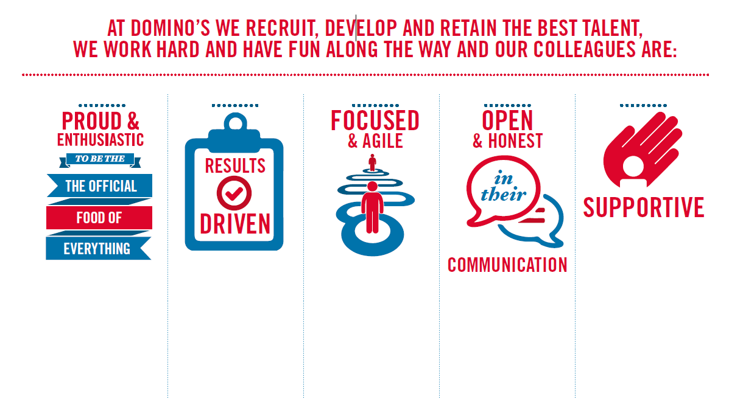
Proud & Enthusiastic: A positive advocate of their brand energises others through their passion.

Results Driven: Exceeds goals, pushes themselves to deliver, gets the job done at pace.

Focused & Agile: Works towards business goals, flexible to adapt and innovate as needed.

Open & Honest: Has sincere and two-way conversations, listens to and respects the views of others.

Supportive: Encourages and helps others, builds relationships, contributes to a positive environment

