Role Title: | General Manager SCC
Location: | Warrington
Reports to Role: | Supply Chain Operations Director
Direct Reports: | 5
Grade: | C
Notice Period: | 3m
Version Number and date: | September 2025

ROLE PURPOSE
The purpose of the role is to effectively develop, hands on manage and control the provision of production and distribution services out of Warrington SCC in line with Domino’s Pizza policies, work procedures and one network approach

This is a key leadership role within supply chain providing a safe and great place to work for our colleagues within this site, whilst delivering exceptional standards and service for our franchisees and stores. The site is managed through strict financial and systems control.

MAIN AREAS OF RESPONSIBILITY
- Make health and safety the highest priority across the SCC’s to ensure everyone returns home safely at the end of each working day.
- Comply with all company processes and procedures to ensure you work in a manner that keeps you and your colleagues safe.
- Direct responsibility for the line management and personal development of the supply chain centre senior team .
- Manage operational costs in line with budgets and forecasts to maximise the performance of the operation in all activities.
- Through inspirational leadership engage, develop and train your team to consistently deliver exceptional standards, great customer service and strong financial controls.
- Manage through appropriate key performance indicators to identify and address areas for improvement
- Facilitate working across boundaries to achieve results and drive a culture of continuous improvement.
- Achieve and maintain FSSC and DPII accreditation ensuring critical controls are identified, monitored and maintained throughout the supply chain centre.
- Review and analyze causes of non-conformity within the supply chain centre operations and by working closely with the site senior team develop and implement process and procedures to eliminate operating problems and improve the quality of service.
- Operate in the role according to Domino’s DNA and business code of conduct.
- Actively participate in Domino’s performance development review process
- Establish effective succession planning within the supply chain centre senior team and all colleagues have comprehensive personal development plans.
- Comply with all applicable UK and Ireland Data Protection and ePrivacy legislation and report non-compliances where identified to the Data Protection team

The main areas of responsibility are not intended to be exhaustive but gives a general indication of the role. It is the nature of the Company that tasks and responsibilities are in many circumstances, unpredictable and varied. All colleagues are therefore, expected to work in a flexible way when the occasion arises and acknowledge that tasks not specifically covered in their role profile are not excluded.

ACCOUNTABILITY
- Ensure the highest standard of health and safety, security and housekeeping across the site.
- Accountable for site achievement of operational and commercial performance targets.
- Ensure customer-centric focus and high levels of service (internal & external).
- Achieve and maintain FSSC / ISO and DPII accreditation.
- Develop and implement a long-term site plan to improve key performance indicators.

KNOWLEDGE, SKILLS, ABILITY & EXPERIENCE
- Passion and working understanding of Health and Safety Legislation. (IOSH or above)
- Operational leadership experience in a fast-paced manufacturing or supply chain environment, with experience of QSR and franchise operations
- Experience of working in automated distribution and transport environments
- Excellent communication skills, both verbal and written.
- Experience and understanding of working to FSSC / ISO accreditation with an understanding of Food Safety Standards
- Strong experience of P&L responsibility with a focus on cost saving initiatives
- High level experience in managing stakeholders across a range of activities and working as part of a network operation

COMPETENCIES
At Domino’s we recruit, develop and retain the best talent, we work hard and have fun along the way, and our colleagues are;
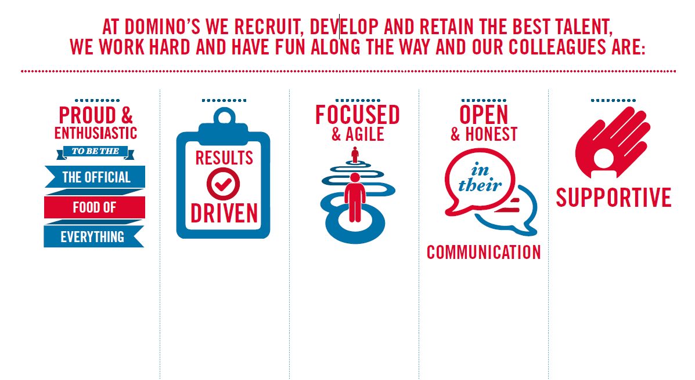
Proud & Enthusiastic: A positive advocate of their brand energises others through their passion.

Results Driven: Exceeds goals, pushes themselves to deliver, gets the job done at pace.

Focused & Agile: Works towards business goals, flexible to adapt and innovate as needed.

Open & Honest: Has sincere and two-way conversations, listens to and respects the views of others.

Supportive: Encourages and helps others, builds relationships, contributes to a positive environment

