Role Title: | Inventory & Demand Planner
Location: | West Ashland, Milton Keynes
Reports to Role: | Inventory & Demand Planning Manager
Direct Reports: | None
Grade: | F
Notice Period: | Normal
Version Number and date: | January 2025

ROLE PURPOSE
The role is responsible for the Demand Forecasting and Inventory Management for a portfolio of products, across multiple temperature regimes, ensuring timely replenishment of stock from our supplier base, into our Supply Chain Centres, (SCC’s), to fully support store and consumer demand.
To work with our global supplier base and hauliers to constantly review and optimize Minimum Order Quantities, Lead-Times and inventory policies to deliver maximum availability while minimizing inventory levels and costs.

MAIN AREAS OF RESPONSIBILITY
- Ensuring optimal inventory levels to meet customer needs while minimizing excess stock
- Working with cross functionally, you will support the creation of forecast for new menu items and ensure stock availability throughout promotional events.
- Provide guidance in problem solving to mitigate unanticipated demands.
- Co-ordinate with SCC’s as necessary, to manage the rebalancing of inventory levels across the network to mitigate potential stock loss or ensure availability is maintained.
- Analyzing historical sales data, market trends, and external factors to predict future product demand
- To liaise with Procurement, Operations, Product Development and Suppliers, to manage slow moving and obsolete stock, minimising risks of stock write off through forecast accuracy and collaborative planning.
- Highlight and discuss capacity challenges across the SCC network, working across all sites to find appropriate solutions.
- Working with data from the Marketing and Finance Teams, create, update, analysis and publish promotional trackers to the leadership teams, summarizing key trends, highlighting potential risks and implementing actions to ensure stock availability for stores and consumers.
- Monitor and control inventory held in third party storage facilities ensuring stock is available as required to each Supply Chain Center.
- To be responsible for supplier performance, tracking & publishing KPI’s, organizing and meeting your supplier base on a regular basis in collaboration with the Procurement Team, establishing root cause for performance challenges, creating, implementing and monitoring performance improvement plans and providing regular updates to Inventory & Demand Planning Manager & Director of Inventory.
- Maintain invoice records to ensure cost is tracked and invoices are paid in a timely manner.
- Comply with all legal and Company policies and procedures regarding health and safety to ensure you work in a manner that keeps you and your colleagues safe.
- Comply with all applicable UK and Ireland Data Protection and ePrivacy legislation and report non-compliances where identified to the Data Protection team
- Responsible for actively participating in Domino’s performance development process to ensure knowledge and skills remain current and relevant for role.
The main areas of responsibility are not intended to be exhaustive, but gives a general indication of the tasks involved. It is the nature of the Company that tasks and responsibilities are in many circumstances, unpredictable and varied. All colleagues are therefore, expected to work in a flexible way when the occasion arises and acknowledge that tasks not specifically covered in their role profile are not excluded.
ACCOUNTABILITY
- Leveraging advanced forecasting tools and data analytics to enhance accuracy, making timely decisions ensuring stock availability throughout the Supply Chain Centers.
- Analyzing historical sales data, market trends, and external factors to predict future product demand and ensure availability and Inventory targets are met in line with KPI’s
- Management of supply transfers across the network.
- To provide regular updates and insights to stakeholders on demand forecasts, inventory status, and supply chain performance

KNOWLEDGE, SKILLS, ABILITY & EXPERIENCE
- Demonstrate good attention to detail working with a high level of accuracy.
- Knowledge and understanding on Inventory planning, ideally within a food industry.
- Intermediate level knowledge of Microsoft Excel as a minimum.
- Knowledge and experience of MRP / ERP systems, preferably Dynamics D365.
- Able to make recommendations using analytical data and able to influence decision making.
- Ability to work on own initiative, to problem solve and make quick decisions.
- Able to work collaboratively with all areas of the business building good internal/external relationships

COMPETENCIES
At Domino’s we recruit, develop and retain the best talent, we work hard and have fun along the way, and our colleagues are;
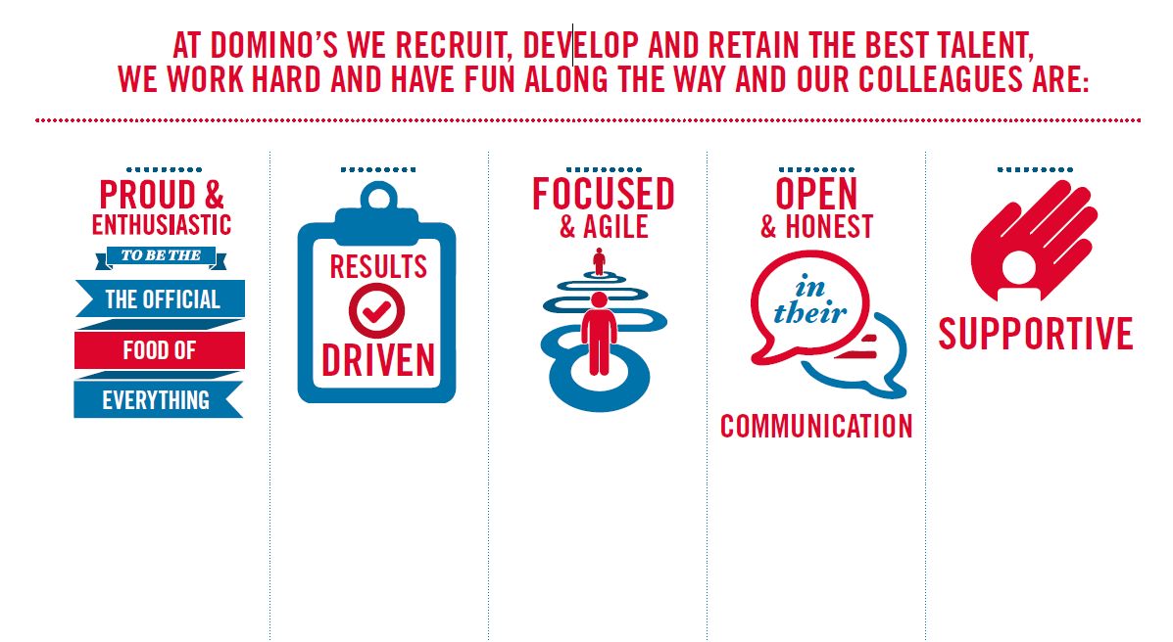
Proud & Enthusiastic: Understading of functional area, acting as a coach to passionately inspire, motivate
and share knowledge with others to achieve success

Results Driven: Sets and maintains high performance standards with ability to problem solve,
motivating self and others to translate action plans in to results

Focused & Agile: Acts with customers in mind at all times, prioritising what will make a difference to
colleagues, customers and franchisees

Open & Honest: Excellent communications skills encouraging two way positive and developmental
feedback at all levels

Supportive: Strong interpersonal and influencing skills to build and maintain networks internally
and across the business to collaboratively achieve results

