Role Title: | Warehouse Operative
Location: | Supply Chain Centres
Reports to Role: | Depot Shift Managers, Warehouse Team Leaders
Direct Reports: | None
Grade: | H
Notice Period: | 4 weeks
Version Number and date: | May 2019

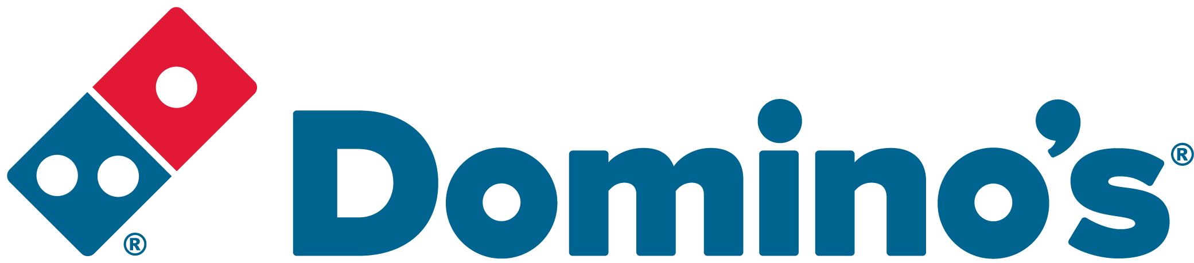ROLE PURPOSE
Accurately receipt product from suppliers, pick product via use of the Warehouse Management System or paper sheets, and load products onto allocated Domino’s vehicles to ensure the correct products are available for delivery to the customer in line with Domino’s Pizza policies and standard operating procedures.

MAIN AREAS OF RESPONSIBILITY
- To check goods in against delivery notes for accuracy and damages.
- Receipt and put-away of delivered product ensuring stock rotation and correct allocation of product dates.
- Accurately pick product for loading, as stated on the picking sheet or WMS and in accordance with the picking procedure and agreed targets.
- Load vehicles accurately, safely and in the right sequence as designated by the vehicle load sheets and in line with Domino’s Pizza policies and standard operating procedures and agreed targets.
- Perform stock take as and when required in line with Company procedures.
- Maintain food safety systems and demonstrate due diligence to cover all loading process, food and non-food items using hazard analysis principles, in line with FSCC and DPII audit requirements
- Continuously review current processes, and proactively seek and implement methods of improvement.
- Comply with all legal and Company policies and procedures regarding Health and Safety to ensure you work in a manner that keeps you and your colleagues safe.
- Comply with all applicable UK and Ireland Data Protection and ePrivacy legislation and report non-compliances where identified to the Data Protection team
- Responsible for actively participating in Domino’s performance development process to ensure knowledge and skills remain current and relevant for role.
The main areas of responsibility are not intended to be exhaustive but gives a general indication of the role. It is the nature of the Company that tasks, and responsibilities are in many circumstances, unpredictable and varied. All colleagues are therefore, expected to work in a flexible way when the occasion arises and acknowledge that tasks not specifically covered in their role profile are not excluded.

ACCOUNTABILITY
- Responsible for ensuring an impressive service delivery to our Franchisee’s, through high quality delivery standards.
- Actively participate in the Domino’s performance development review process

KNOWLEDGE, SKILLS, ABILITY & EXPERIENCE
- Previous similar experience in a Warehouse environment, ideally within a food service environment
- A good understanding of Health and Safety and Food Safety legislation
- Manual Handling certificate
- MHE experience would be desirable

COMPETENCIES
At Domino’s we recruit, develop and retain the best talent, we work hard and have fun along the way, and our colleagues are;
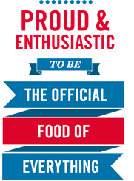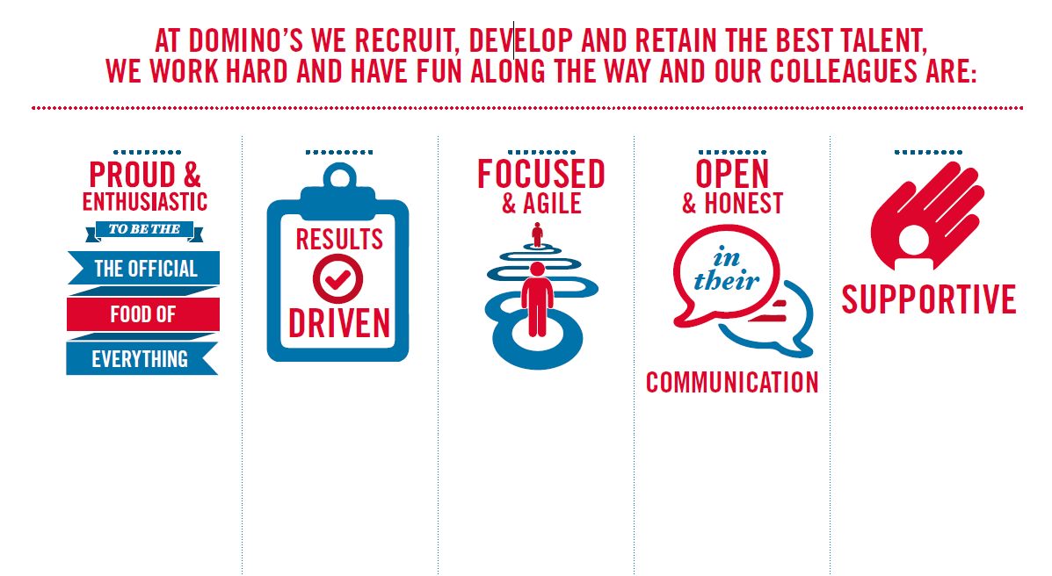
Proud & Enthusiastic: A positive advocate of their brand energises others through their passion.

Results Driven: Exceeds goals, pushes themselves to deliver, gets the job done at pace.

Focused & Agile: Works towards business goals, flexible to adapt and innovate as needed.

Open & Honest: Has sincere and two-way conversations, listens to and respects the views of others.

Supportive: Encourages and helps others, builds relationships, contributes to a positive environment

