Role Title: | Driver Support
Location: | Supply Chain - Cambuslang
Reports to Role: | Transport Manager
Direct Reports: | None
Grade: | H
Notice Period: | 4 weeks
Version Number and date: | Version 1: March 2021

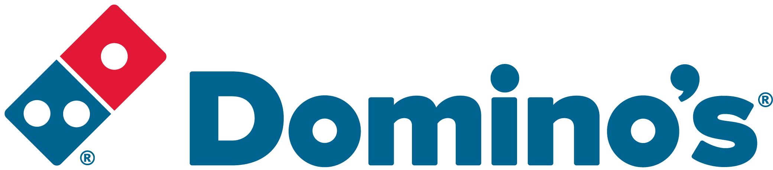ROLE PURPOSE
Ensure the cleanliness and readiness of the Domino’s vehicle fleet in line with Domino’s policies and standard operating procedures, whilst ensuring the transport yard and adjacent areas are maintained at all times. Ensure the accurate, safe and timely delivery of goods to Domino’s Pizza Stores throughout the UK and Ireland in line with Domino’ Pizza policies and standard operating procedures.

MAIN AREAS OF RESPONSIBILITY
- Make Health & Safety a priority by complying with all legal and Company policies and procedures to ensure you work in a manner that keeps you and your colleagues safe.
- Ensure vehicles are cleaned and ready for use in a roadworthy condition in line with demand and in accordance with Domino’s Pizza policies and standard operating procedures, whilst safely using all cleaning chemicals required
- Ensure that the yard and adjacent areas are maintained to an appropriate level of cleanliness and cleaning duties are performed as required e.g. litter picking, washing etc.
- Control the movement of vehicles within the yard ensuring the correct vehicles are available for loading and loaded vehicles are removed from the bays in a timely manner.
- Ensure all vehicles are fueled prior to departure and all daily vehicle checks are performed to ensure the vehicles are safe for use by HGV drivers.
- Ensure any vehicle defects, vehicle accident or damage, personal injury accident or damage to product or Domino’s Pizza Store are reported to the direct Line Manager at the earliest opportunity.
- Support Drivers and the Warehouse Team in the loading and unloading of vehicles when required and at Domino’s Pizza Stores, collecting empty dough trays, cages, dollies and tote baskets from Domino’s Stores.
- Delivery of goods into Domino’s Pizza Stores; placing goods in the designated areas whilst ensuring accuracy and checking the goods delivery against the delivery paperwork.
- Ensure high customer service standards are maintained at all times.
- Comply with all Transport legislation including Working Time Directive, EU Driver’s Hours and Tachograph laws.
- To comply with all Company procedures ensuring that all paperwork associated with the role is completed accurately and returned to the Central Office in a timely manner.
- Notify the Central Office at the earliest opportunity of any delays to your deliveries, if you are unable to make a delivery or if you are likely to run out of driving hours prior to completing all your deliveries.
- Proactively seek methods of continuous improvements within the department and propose these to Managers.
- To assist Drivers in deliveries and conduct Driver pick-ups as and when required.
- Transportation of vehicles between site and Vehicle Service Company to support the collection and delivery of vehicles for repair, maintenance and service subject to holding the appropriate class of vehicle license.
- Comply with all applicable UK and Ireland Data Protection and e-Privacy legislation and report non-compliances where identified to the Data Protection team
- Responsible for actively participating in Domino’s performance development process to ensure knowledge and skills remain current and relevant for role.
The main areas of responsibility are not intended to be exhaustive but gives a general indication of the role. It is the nature of the Company that tasks and responsibilities are in many circumstances, unpredictable and varied. All colleagues are therefore, expected to work in a flexible way when the occasion arises and acknowledge that tasks not specifically covered in their role profile are not excluded.

ACCOUNTABILITY
- Ensure legal compliance and co-operate with Company policy and procedure relating to ISO Standards and Food Hygiene Standards whilst in performance of duties and on Company premises.
- To maintain an up to date knowledge of all regulations related to their responsibilities.
- Continue to develop own talents and strengths and address any areas of self-development

KNOWLEDGE, SKILLS, ABILITY & EXPERIENCE
- Previous similar experience ideally gained within a Transport environment.
- An understanding of Health and Safety Legislation and Food Safety Standards
- Experience of driving HGV vehicles
- LGV C1, C+E license ideally with no penalty points would be desirable

COMPETENCIES
At Domino’s we recruit, develop and retain the best talent, we work hard and have fun along the way, and our colleagues are;
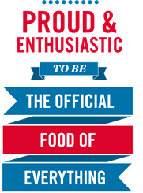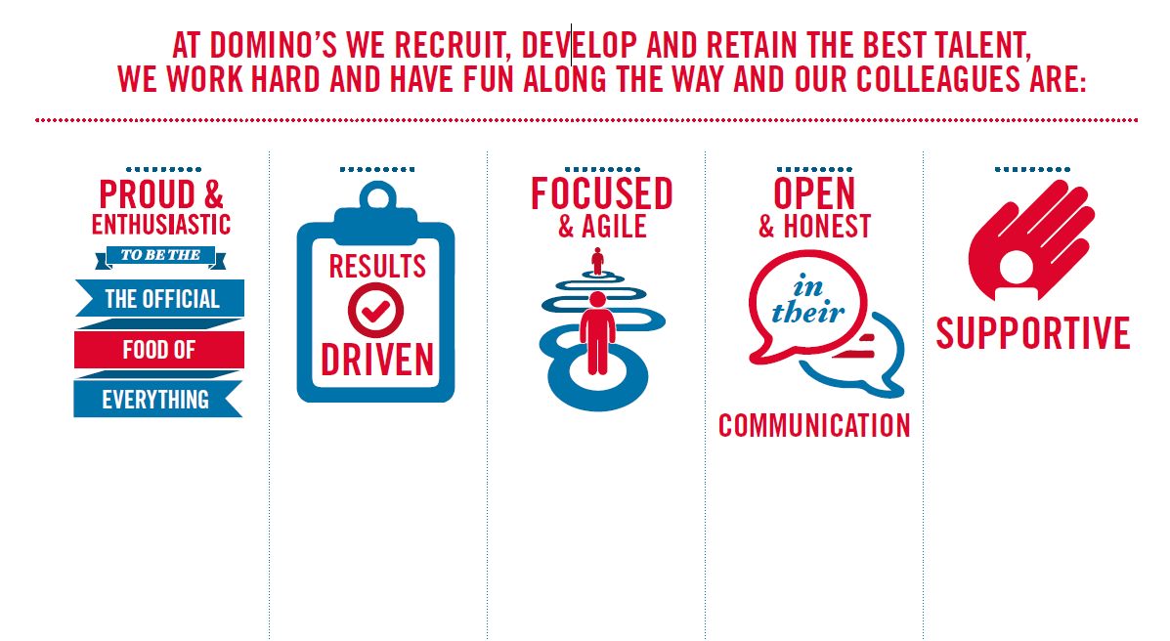
Proud & Enthusiastic: A positive advocate of their brand energises others through their passion.

Results Driven: Exceeds goals, pushes themselves to deliver, gets the job done at pace.

Focused & Agile: Works towards business goals, flexible to adapt and innovate as needed.

Open & Honest: Has sincere and two-way conversations, listens to and respects the views of others.

Supportive: Encourages and helps others, builds relationships, contributes to a positive environment

