Role Title: | Store Ordering Team Leader
Location: | West Ashland Milton Keynes
Reports to Role: | Store Ordering Manager
Direct Reports: | None

ROLE PURPOSE
As the Stores Ordering Team Leader, you will play a pivotal role in ensuring the smooth operation of the Store Ordering function. You will act as the primary escalation point for the team, provide day-to-day leadership, and support strategic initiatives. All food and non-food orders received from Domino’s Pizza stores, will be processed accurately and in a timely manner in line with agreed standards and procedures, whilst providing exceptional customer service to our internal customers, stores, Franchisees. This role requires strong team leadership, decision-making capabilities, excellent communication skills, and a proactive approach to problem-solving.

MAIN AREAS OF RESPONSIBILITY
- To be the first point of escalation for the Store Ordering Team, ensuring timely and effective resolution of issues.
- Lead and manage the team in the absence of the Store Ordering Manager, maintaining operational standards and service levels.
- Oversee weekend operations, managing team availability and absences to ensure continuity of service.
- Maintain high standards of professionalism and customer service when handling store and franchisee queries, ensuring responses are within agreed KPIs.
- Represent the Store Ordering Team in cross-functional projects, contributing subject matter expertise to support informed decision-making.
- Attend supplier and internal business meetings, providing input and making decisions on behalf of the team and manager when required.
- Collaborate with Innovation and Inventory teams to support product trials and launches, ensuring accurate system setup and operational readiness.
- Compile and distribute weekly management reports for senior leadership, highlighting key metrics and performance insights.
- Produce daily, weekly, and monthly reports for SCC leadership and UKLT, ensuring accuracy and timeliness.
- Collate and share daily dough volume data with Warehouse and Production teams to support supply chain planning.
- Support recruitment activities by reviewing CVs, coordinating interviews, and assessing candidate suitability.
- Deliver and oversee induction and training programs for new starters, ensuring they are equipped to perform core tasks effectively and on schedule.
- Promote continuous development within the team through coaching, mentoring, and performance feedback.
- Accurately process store orders using our internal system, DOMCOM and Microsoft D365 system, ensuring daily deadlines are met.
- Identify and resolve missed store orders, raising a ‘Ghost’ order to maintain operational flow.
- Manage & raise emergency food deliveries, coordinating with SCC teams and communicating updates to stores promptly.
- Respond to store and franchisee queries via phone and email, providing professional, friendly, and effective support.
- Triage and process as a team, approximately 30,000 monthly emails, ensuring timely resolution or escalation.
- Investigate and resolve short delivery claims, coordinating with SCC teams and issuing credits or re-deliveries as appropriate.
- Manage FEWS portal submissions, ensuring claims are investigated and closed within agreed timelines.
- Resolve escalated complaints efficiently, involving senior stakeholders when necessary.
- Assist in creating work rotas & schedules, ensuring adequate coverage and effective task delegation.
- Prioritise and assign tasks to team members based on business needs.
- Foster a positive and collaborative team culture, encouraging accountability and continuous improvement.
- Monitor team performance and provide feedback to support development and goal achievement.
- Identify process improvement opportunities and contribute to the implementation of best practices.
- Comply with all legal and Company policies and procedures regarding health and safety to ensure you work in a manner that keeps you and your colleagues safe.
- Comply with all applicable UK and Ireland Data Protection and ePrivacy legislation and report non-compliances where identified to the Data Protection team
- Responsible for actively participating in Domino’s performance development process to ensure knowledge and skills remain current and relevant for role.

The main areas of responsibility are not intended to be exhaustive but gives a general indication of the tasks involved. It is the nature of the Company that tasks and responsibilities are in many circumstances, unpredictable and varied. All colleagues are therefore, expected to work in a flexible way when the occasion arises and acknowledge that tasks not specifically covered in their role profile are not excluded.

ACCOUNTABILITY
- Lead day-to-day team operations and act as first point of escalation, while making quick decisions
- Point of contact for food/non-food orders from stores, to communicate to internal stakeholders daily
- Accurately upload all order information to tight deadlines
- Maintain high service standards and professional customer service levels of service.
- Understand and action store complaints appropriately, notify any trends and to close out.

KNOWLEDGE, SKILLS, ABILITY & EXPERIENCE
- Proven leadership in a fast-paced, customer-focused environment.
- Strong decision-making, communication, and problem-solving skills.
- Experience within a customer focused role understanding implications of service levels
- Demonstrate good attention to detail working with a high level of accuracy
- Intermediate level knowledge of Microsoft Excel as a minimum.
- Able to work collaboratively with all areas of the business building good internal relationships
- Flexible approach required to work rotating shifts, between 6am-5pm, 7 days a week.

COMPETENCIES
At Domino’s we recruit, develop and retain the best talent, we work hard and have fun along the way, and our colleagues are;
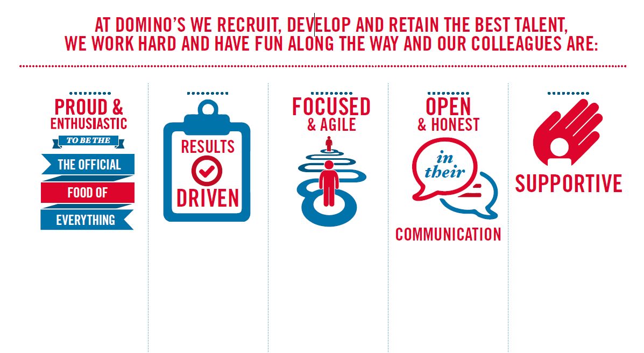
Proud & Enthusiastic: Understading of functional area, acting as a coach to passionately inspire, motivate
and share knowledge with others to achieve success

Results Driven: Sets and maintains high performance standards with ability to problem solve,
motivating self and others to translate action plans in to results

Focused & Agile: Acts with customers in mind at all times, prioritising what will make a difference to
colleagues, customers and franchisees

Open & Honest: Excellent communications skills encouraging two way positive and developmental
feedback at all levels

Supportive: Strong interpersonal and influencing skills to build and maintain networks internally
and across the business to collaboratively achieve results

